A1136-Afr-Egy-Amulet-Horus-Middle Kingdom-Amenemhat III-1853-1805 BCE-Alabaster

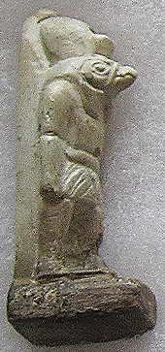 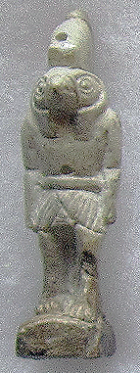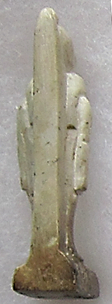

Figs. 1-3. Amulet-Horus-Middle Kingdom-Amenemhat III-1853-1805 BCE-Alabaster

**Case No.: 2**

**Formal Label:** Amulet-Horus-Middle Kingdom-Amenemhat III-1853-1805 BCE-Alabaster

**Display Description: This alabaster amulet of Horus as a falcon in his anthropomorphic form is wearing the crown of Upper Egypt and dressed in a kilt. His left foot is extended. A plinth is placed at his back, and he stands on a rectangular platform. A very similar amulet was excavated and photographed by W. M. Flinders Petrie at Hawara in 1888 (Petrie 1914, pl. 180f).**

**Accession Number: A1136.**

**LC Classification:** DT62.A5

**Date or Time Horizon:** Middle Kingdom-Amenemhat III-1853-1805 BCE

**Geographical Area: Hawara, Fayoum depression, Egypt.**

**Map, GPS Coordinates:** 29°14'10.89"N, 30°58'14.38"E

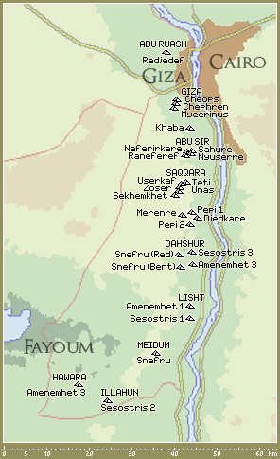 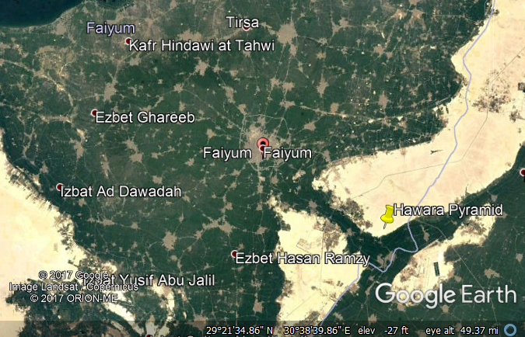

Fig. 4. Map of pyramids showing relative location of Amenemhat III’s pyramid at Hawara.

Fig. 5. Google Earth map of Hawara Pyramid area.

**Cultural Affiliation:** Middle Kingdom-Amenemhat III

**Medium:** Alabaster

**Dimensions: 69.64 mm; 2.74 in.  
Weight: 31 gm; 1 oz.**

**Provenance: W. M. Flinders Petrie, 1888, then an English Collection.**

**Condition:** original

**Discussion:** Because Horus was worshipped as the heroic victor in his battle with the god of chaos, Seth, these amulets were believed to protect the wearer from hostile forces.

**References:**

Petrie, W. M. Flinders. 1914. *Amulets*. London: Constable & co. ltd.